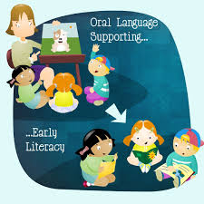
How Does Oral Language Play into the
Development of Reading and Writing

CESA #12 Conference Center

April 10, 2015

Registration: 8:30 - 9:00 AM

Training: 9:00 AM - 3:30 PM

Overview
Dale Bailey, WI Statewide Early Literacy Coordinator, will be connecting and deepening the understanding of the relationship between oral language development (listening and speaking) and written language (reading and writing), and why this is such an important topic during the early years of a child. We will look at assessment, formal and informal, of these areas and discuss instruction strategies and programming that support oral language and reading and writing development.

Presenter
Dale Bailey, M.A., CCC-SLP Speech-Language Pathologist & WI Statewide Early Literacy Coordinator.
Dale was initially licensed as a speech-language pathologist and primarily provided speech-language evaluation, therapeutic, and consultation services Birth to 6 for approximately 8 years in Maine. Interests to language and literacy development led to Dale becoming certified to conduct Learning Disability (LD) evaluations and provide LD consultation. Over a 10-year period, Dale conducted individualized LD evaluations and worked with hundreds of individuals with learning challenges and learning disabilities (K-12), including reading disabilities such as dyslexia. Dale has consulted extensively on the connection between oral language and written language. He has also provided continuing education to general education and special education teachers and has consulted in the areas of assistive technology, learning curriculum access/adaptation and data/school improvement.

Wisconsin State Performance Plan Indicators & Standards Addressed
Wisconsin Teacher Standards Addressed:
Wisconsin State Performance Plan Indicators: 7

Target Audience
Special Education Teachers, 4-Year old Kindergarten and Early Childhood Education Teachers, Head Start Teachers, Special Education Directors, Child Care Providers
Other interested education professionals.

Registration Fee
Free - This professional development opportunity is supported through funding from Preschool Discretionary Grant 14-74-9912-PIDEA60 (CFDA #84.173).

Substitute and mileage is available for Early Childhood Program Support participating school districts only.
(Ashland, Bayfield, Butternut, Drummond, Hayward, Hurley, Maple, Mellen, Mercer, Phillips and Washburn)

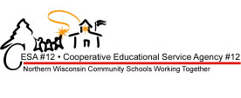
Deadline for Registration
April 7, 2015
TO REGISTER – GO TO: WWW.MYQUICKREG.COM

